

**Distributed Query Tool**

**Investigator Manual**

**Powered by PopMedNetTM**

Based on release 3.2

May 2013

**CONTACTS:**

Jeffrey Brown, PhD

Harvard Pilgrim Health Care Institute

[Jeff_brown@hphc.org](mailto:Jeff_brown@hphc.org)

The **PopMedNet**TM application was developed under the Agency for Healthcare Research and Quality, US Department of Health and Human Services as part of the Developing Evidence to Inform Decisions about Effectiveness (DEcIDE) program, awarded to the DEcIDE centers at the HMO Research Network Center for Education and Research on Therapeutics (HMORN CERT) and the University of Pennsylvania. The Food and Drug Administration’s Mini-Sentinel project provided additional support.

Contents

1 Introduction 1

2 System Overview 2

3 How to Login to the Web Portal 4

4 Project Based Requests 8

5 Submitting a Request 10

5.1 Scheduling Requests 11

6 Request Types 15

6.1 ESP Query Builder Queries 15

6.1.1 ESP ICD-9 Diagnosis Query 16

6.1.2 ESP Reportable Disease Query 19

6.2 File Distribution 21

6.3 SQL Distribution 24

7 Checking the Query Status 27

8 Viewing Request Results 30

9 Exporting Result Data 33

10 Adding or Removing DataMarts from Submitted Queries 34

11 Administering your User Profile 36

11.1 How to Reset your Password 36

11.2 Notifications 38

12 Getting Help 41

13 Development and Funding Statement 42

14 Frequently Asked Questions 43

Appendix A: Quick Reference for Investigators 45

Appendix B: Query Administrator Role 46

**Document History**

The following table is a revision history for this document.

Table : Document History

|  |  |  |  |
| --- | --- | --- | --- |
| **Version** | **Author(s)** | **Date** | **Description** |
| 3.1 | Lincoln Peak Partners | 11/15/2012 | Created. |
| 3.2 | Jeff Brown, Elizabeth Balaconis, Megan Mazza, Melanie Davies | 5/13/2013 | New Build. This new documentation represents a new release of the PMN software. Prior Mini-Sentinel query tool documentation was based on release 2.3.24 and this documentation is based on PMN 3.2.0. New features include User Registration, Plug-in Architecture, Security Group Access Control, and Projects. |

# Introduction

The MDPHnet (Massachusetts Department of Public Health Network) Distributed Query Tool is based on the **PopMedNet™** software application that enables simple, efficient creation and use of distributed data networks, through a set of tools and web-based services. It is optimized to facilitate distributed analyses of medical product safety, comparative effectiveness, quality, medical resource utilization, cost-effectiveness, and related studies. The system provides secure, customized private portals, query tools, and file transfer capabilities. It supports both menu driven queries and distributed analyses using complex, single use or multi-use programs designed to execute against a local data resource.

Data partners exercise full control over the files they make available for querying, the results returned to requestors, and the individuals who are permitted to submit queries.

This MDPHnet Investigator Manual describes the main features and functions for Investigators participating in a health data network powered by PopMedNet™ software. Investigators will primarily interact with the PopMedNet™ network through a secure web-based portal as described below. Different networks will have different types of queries and capabilities. PopMedNet™ software can customize and brand the network as desired.

The Department of Population Medicine at the Harvard Pilgrim Health Care Institute (HPHCI) led development of the system in collaboration with Lincoln Peak Partners (LPP). Lincoln Peak Partners provides support services and secure hosting for current system users, and leads development of system enhancements.

# System Overview

The DistributedQuery Tool software is comprised of two separate applications, the web-based **Portal** and the **DataMart Client**. There is one Portal in the network and each data partner has one or more “DataMarts”. The Portal is the starting point for all information requests and controls all system communications, security, and governance policies. Data Partnersreceive queries, process them, and securely return them to the Portal via their locally installed DataMart Client software application. Each Data Partner will have at least one DataMart; multiple DataMarts per Data Partner are possible. Each DataMart can contain different types of data and DataMarts can have different query processing settings. All query requests and communications within the network are securely routed from the Portal to the DataMarts and then back to the Portal.

**Note:** The term **DataMart** is used in an information technology context referring to the place where the data are held for querying. Use of this term does not imply that data partner information is being sold or being made broadly available; Data Partners maintain control of all their data and all uses.

**Browser Requirements**

The Portal is designed to work with Internet Explorer (IE) 8 or later. Earlier versions of IE may not display the user interface properly. Although IE8 is the only officially supported browser, other browsers such as Firefox and Chrome may also work; Firefox has been used extensively in testing.

**The DataMart Client Application**

The DataMart Client application allows the DataMart Administrator to view queries distributed to the DataMart, execute queries locally, review the results, and upload the results to the Portal. The DataMart Client is a .NET/C# Windows desktop application developed by LPP that is installed locally on an Administrator’s desktop. Note the DataMart Client requires Microsoft .NET 4 to be installed on the user’s desktop. The free download for Microsoft.NET4 is available at the following link: <http://www.microsoft.com/enus/download/details.aspx?id=17851>. All communications between the DataMart Client application and the Portal use HTTP/SSL/TLS connections to securely transfer queries and results between the application and the Portal. The application uses ODBC connections to the local DataMart databases used to process queries and generate results.

**Audience**

This manual is intended for MDPHnet Investigators who want to:

* Get started accessing the Distributed Query Tool
* Submit a query to the available DataMarts
* Monitor status of a query
* Review results of a query

**Investigator Security Groups**

Security Groups determine the rights that individual users have when using the Portal. There are three Investigator security groups that are available within the system.

**Investigator**: can submit requests to DataMarts that have given them or their organization permission to submit queries and view only aggregated request results.

**Enhanced Investigator**: can submit requests to DataMarts that have given them or their organization permission to submit queries and review their requests results. This role has the additional right to view disaggregated (site-specific) results.

**Query Administrator**: can approve requests before they are sent to DataMarts. This user has the rights of an Enhanced Investigator for sending and reviewing requests.

A user may be a member of one or more Security Groups thereby inheriting the rights of all the security groups.

**Related Documents**

For more information about the PopMedNet™ system, see one of the following documents available on the Resources page on the portal or the PopMedNet™ public website (popmednet.org):

**PopMedNet™ Distributed Query Tool DataMart Administrator Manual**

* The *DataMart Administrator Manual* describes the tasks and activities required to install and manage a DataMart. This includes:
* Setting up and configuring the physical environment -- consisting of Internet connectivity/desktop computer requirements, and system software
* Installing and performing initial administrative setup of a DataMart Client
* Managing the DataMart setting in the portal

**PopMedNet™ Distributed Query Tool Overview and Administrator’s Guide**

The *Overview and Administrator’s Guide* describes the overall network system architecture, key querying features, and hosting and security details. This includes:

* System overview and workflow
* Policies and features
* Technical architecture and security
* Installing an instance of a Portal and an associated database
* Performing the initial administrative setup
* Performing typical System Administrator functions such as adding new users and DataMarts, creating new roles, and deleting users and DataMarts

***Note: The descriptions below refer to a specific implementation using the PopMedNet™ software. Installations for other PopMedNet™- powered networks may have different query capabilities.***

# How to Login to the Web Portal

Before you can login to your Distributed Query Tool portal, you need to register for a new account. Once the Network Administrator or the PopMedNet™ support staff approves your credentials and assigns your security groups, you will receive an email notification. Once you have your Login Credentials, follow the steps below.

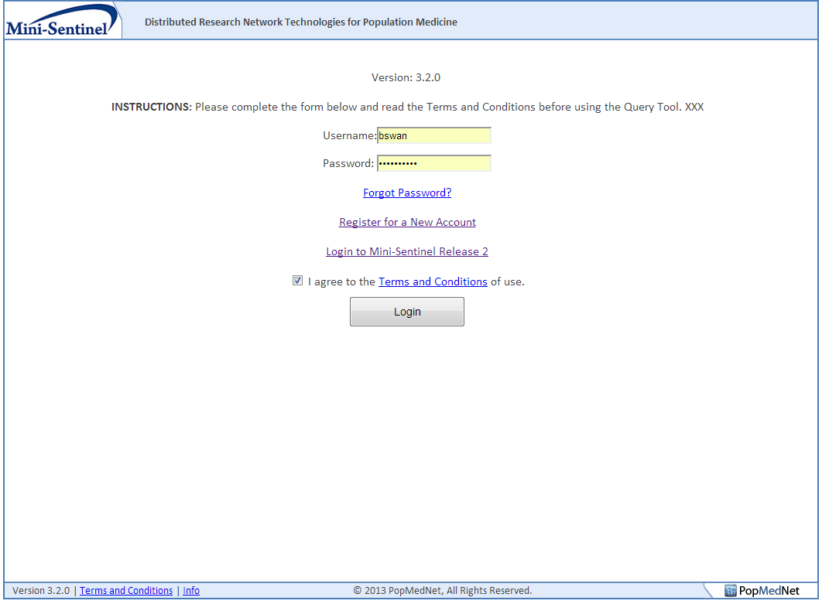

Figure : Logon Page

Use these steps to login to the portal:

1. Navigate to the MDPHnet website login page:  
   [Secure URL distributed by network coordinating center.]
2. Enter your Username and Password in the boxes.
3. If this is your first login, you will be prompted to read and acknowledge your agreement to the Terms and Conditions of use. If you have cookies enabled, you will not be prompted on subsequent logins.
4. Click the Login button to enter the Portal.

Once you have logged in, the portal displays the home page shown below. From the home page, you can view your notifications, view existing requests, and create a new request. This section tells you how to create a request, view its status and results.

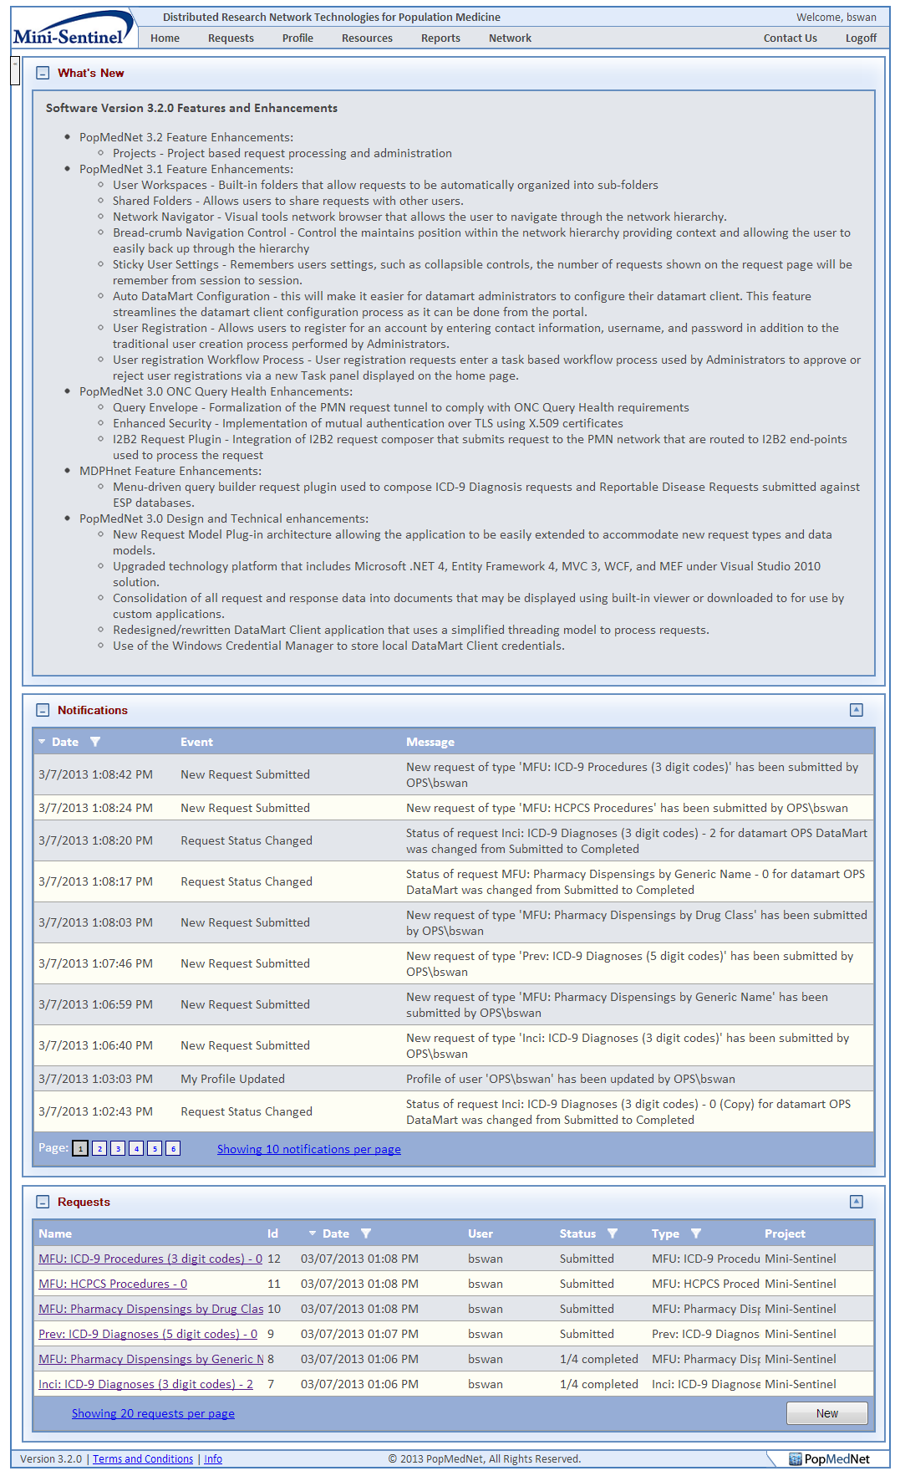

Figure : Home Page

The home page is a landing page that contains a set of controls that provide the user with recent information that is relevant to his daily tasks.

The following controls are available on the home page:

* What’s New message panel – used to communicate system wide information site upgrades, new features and functions
* Notifications – list of recent notifications on requests and responses performed or associated with the user
* Requests list – recent requests that have been initiated by the user or require the user’s approval or review

Collapsible content panels are used throughout the user interface that allows the user to collapse, expand, and maximize the content panel within the page. Additionally, for panels that contain grid controls, the user may specify the number of items displayed in the grid, set column sort orders, and column filters. All these settings are preserved across user sessions.

**Note: The term “Request” is used interchangeably with “Query”. With the introduction of PopMedNet Release 3, the application has the ability to compose and route a variety of queries, commands, and general *requests* to DataMarts through a “plugin” framework that allows the network to be easily extended to introduce new requests types.**

# Project Based Requests

One of the major enhancements in PMN v3.2 is the introduction of Projects. Projects allow networks to group activities within one or more Projects. A project establishes security policies for composing and executing requests for users and DataMarts assigned to the project. Projects are created within an organizational Group. Groups have one or more member organizations whose users and DataMarts may participate within projects owned by the group. Note that the network may have one or more groups, and an organization may be a member of one or more groups.

The following figure shows a Group detail page along with a Group and Organizational structure displayed in the PMN Network Browser control.

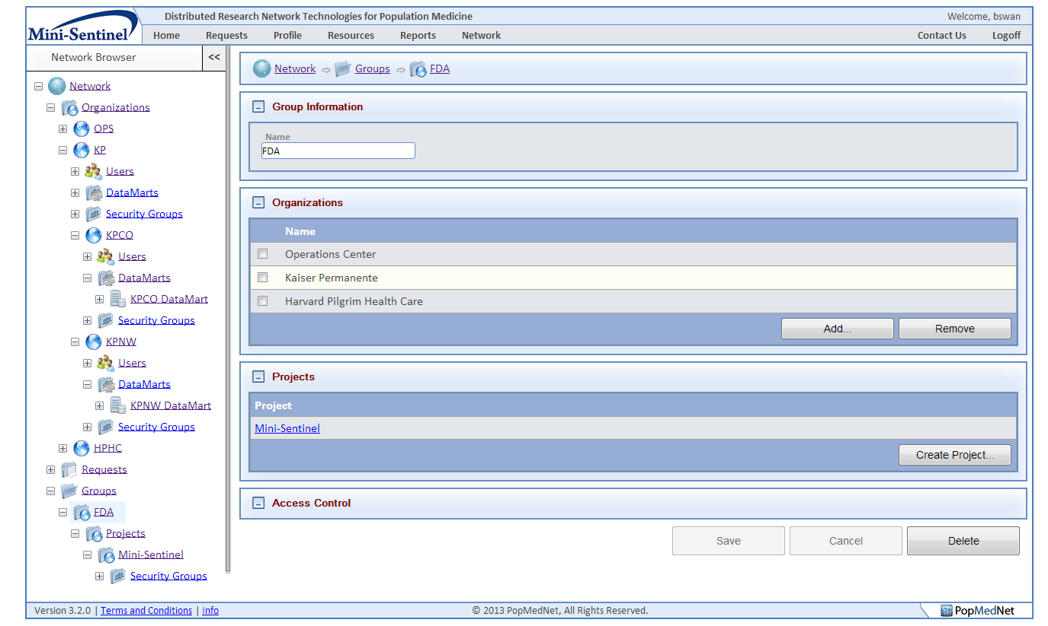

Figure : Group Page and Network Browser Control

In this sample network, there is a single Group called FDA that contains three member organizations and a single project called Mini-Sentinel. Only users and DataMarts defined in each of the member organizations, Operations Center, Harvard Pilgrim Health Care, and Kaiser Permanente including its sub-organizations, may participate in Mini-Sentinel project owned by the FDA group.

Network administrator or users, such as Group and Project administrators, who have rights to modify and administer the Groups, Organizations, and Projects may grant access to a project and configure its security policies. See the PopMedNet Overview and Administrator’s Guide for more information.

Once a group is created and its member organizations are assigned to it, one or more projects may be created. The following figure shows a project detail page used to configure the security policies affecting users and DataMarts assigned to the project.

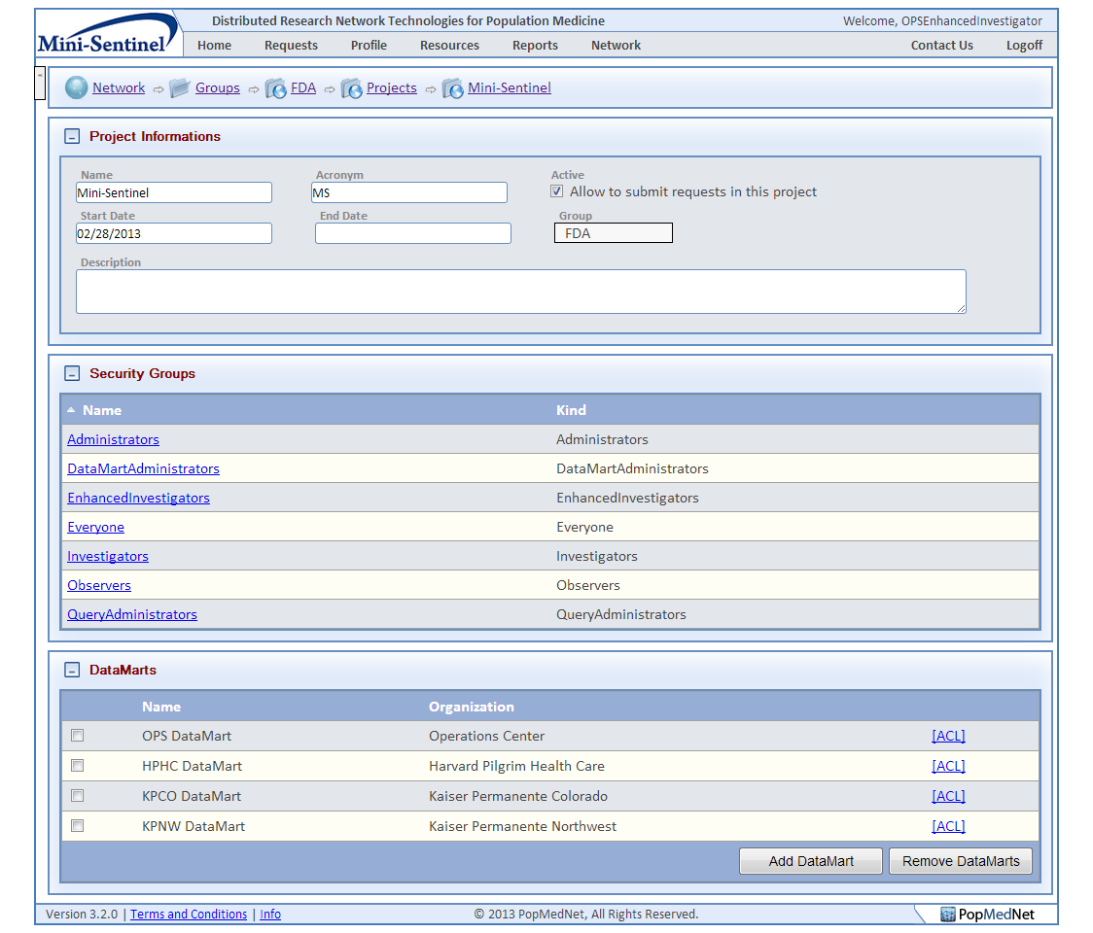

Figure : Project Page

The Mini-Sentinel project may be configured to allow requests to be composed by users of the Operations Center, Kaiser Permanente, and its sub-organizations KP Northwest and KP Colorado, and Harvard Pilgrim Health Care. Additionally, review and approval policies may be defined on requests and their execution within the Mini-Sentinel project.

# Submitting a Request

The Requests panel lists the queries that have been composed by the user. A full page dedicated to requests is available by clicking the Requests menu item at the top of the page. The following figure shows the Requests page with project tabs along the top of the page.

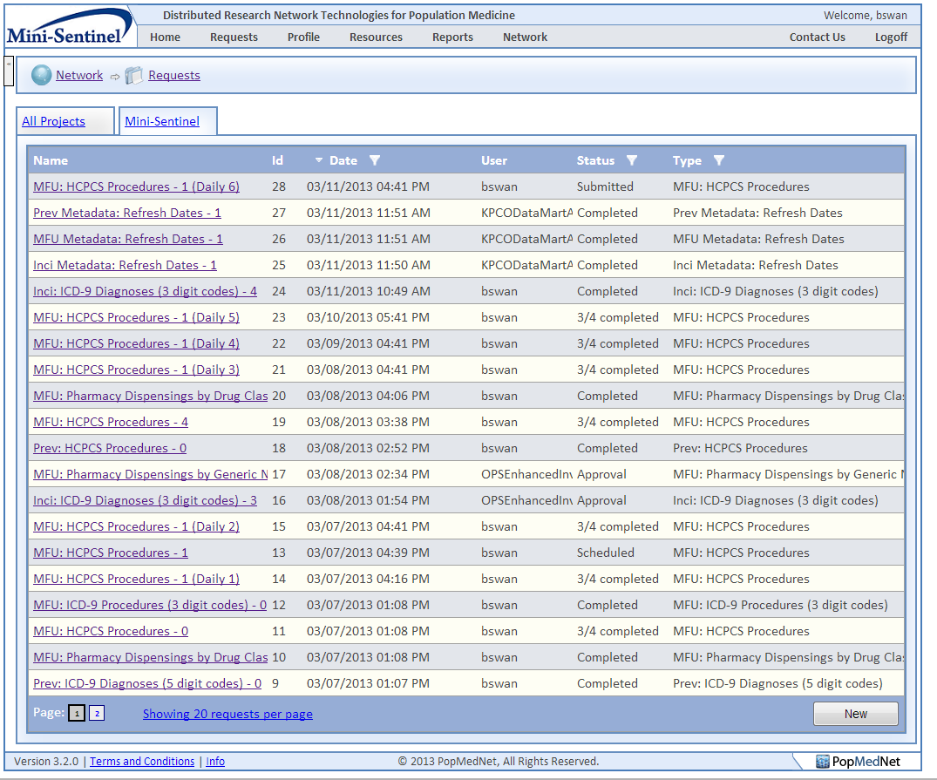

Figure : Request Page

The Requests Page allows you to create menu-driven queries within a selected Project. The criteria that you can enter vary for each type. However, the basic steps are the same for all requests. Once you select a query type, the page shows a common header panel that identifies the request, a common footer panel that contains the DataMarts where the request will be routed, and a content panel in the middle that displays controls used to enter criteria settings for the particular request type.

**Procedure**

Follow these basic steps to submit a request:

1. Click the “New” button in the request panel and choose the request category from the drop down menu.
2. Choose a request model and type from the drop down menu.
3. Enter a unique name for the request in the text box. This name should help you distinguish among your requests. Note that this field only appears after you select the request type.
4. Enter a brief description of the request and the reason for submitting this request, for example to assess the utilization of a medical product. This description is distributed along with the request and should be detailed enough to allow data partners to assess the reason for the query. This step also displays your email address. To update your email address, navigate to your **Profile** by clicking the Profile menu item at the top of the page. You must use a business email address, not a personal account.
5. Specify the project for the request. Note the project will default to the project selected in the project tab control at the top of the Requests page. If the request was initiated from the home page, the project will need to be assigned manually.
6. Specify the request specific criteria and settings for the request type.
7. The available DataMarts that you have rights to route the request to will be listed in the DataMart Routing panel at the bottom of the request page. Select one or more of the DataMarts to execute the request.
8. Click the Submit button to submit the query. The request goes out to all the DataMarts that you have selected. You may click the Save button to save the request to a Draft status to be re-opened later and resume composing the request before submitting it.

## Scheduling Requests

Requests may be scheduled to run in the future rather than immediately when the user clicks Submit by specifying the “Run Mode” on the request detail page.

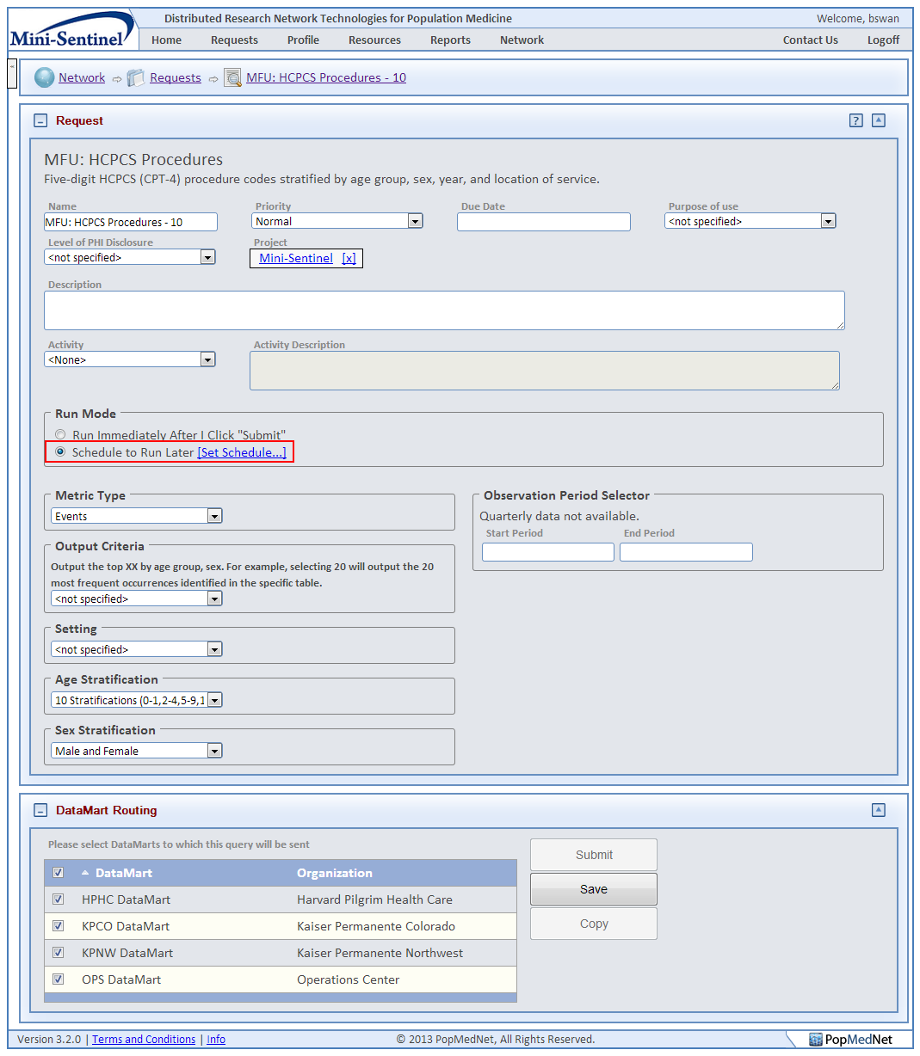

Figure : Request Composer Page - Scheduler Function

To schedule a request, click the “Schedule to Run Later” radio button in the Run Mode group on the request detail page. This will display a “Set Schedule” link that will display a popup dialog box that provides in interface to choose a recurrence pattern and date range to run the request.

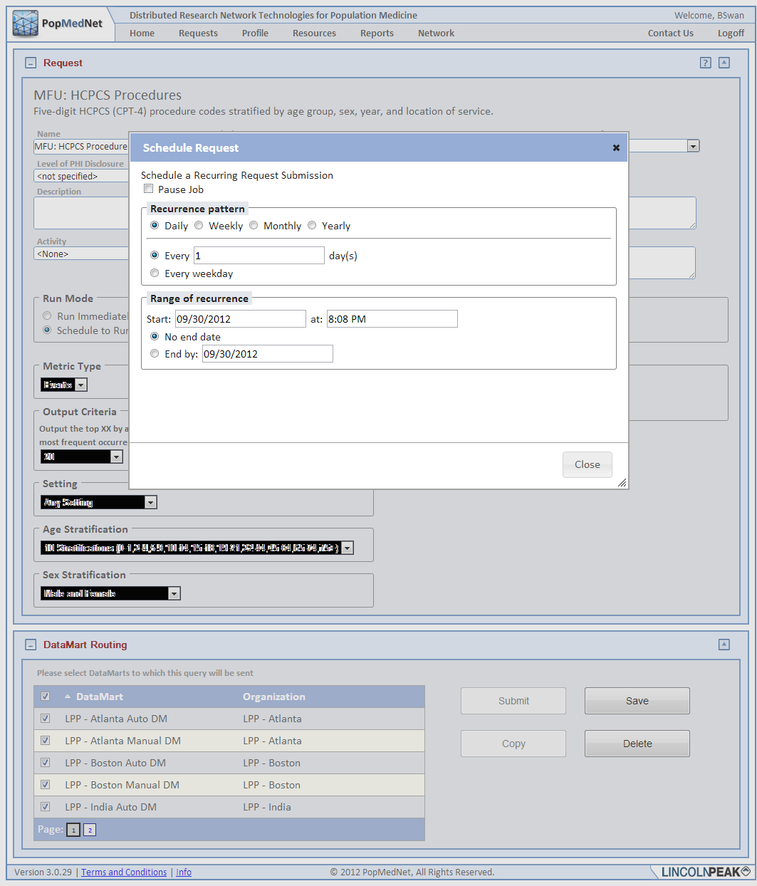

Figure : Schedule Request Dialog

Once the schedule is set and the request saved, the request is now scheduled to run based on the settings you’ve entered. You’ll notice that the request status goes to “Scheduled”. When the date/time comes to run the request, a copy of the request is made and submitted to the DataMarts that were selected in the base request with its name modified to reflect the scheduled copy (e.g. *BaseRequestName_Weekly_1*). Once submitted, the request behaves like any other request that was submitted.

This request’s schedule may be adjusted by opening the base request, modifying the request or schedule, and re-saving it. A request can be unscheduled by changing the Run Mode to “Run immediately” and saving the request. This will place the request into a Draft mode.

# Request Types

MDPHnet currently supports a number of request types:

* Menu-driven queries that execute against ESP databases
* File distribution queries used to exchange documents between the portal and DataMarts
* SQL distribution queries use to distribute raw SQL between the portal and DataMarts



## ESP Query Builder Queries

The *Electronic Support for Public Health* (ESP) Query Builder is a set of requests that operate against the ESP database. ESP uses a set of complex algorithms to identify selected diseases of public health concern such as acute hepatitis B, Lyme disease, influenza-like illness, and diabetes. The ESP algorithms are based on the ESP data model that is a standardize representation of EHR-based encounter and patient demographic information. The ESP platform enables automated extraction of data from EHRs into a format suitable for disease surveillance activities. ESP is installed behind the provider’s firewall, giving the provider control access over access and use of their data.

The requests supported by ESP Query Builder are:

* ICD-9 Diagnosis – used to build ad-hoc custom health measure queries based on ICD-9 3-digit, 4-digit, and 5 digit diagnosis codes that produce reports stratified by ICD-9 code, period, gender, race, and age range.
* Reportable Diseases – used to select one of a list of reportable disease reports that are produced periodically on the ESP servers stratified by period, gender, race, and age range.

The following sections describe how you can create these request types.

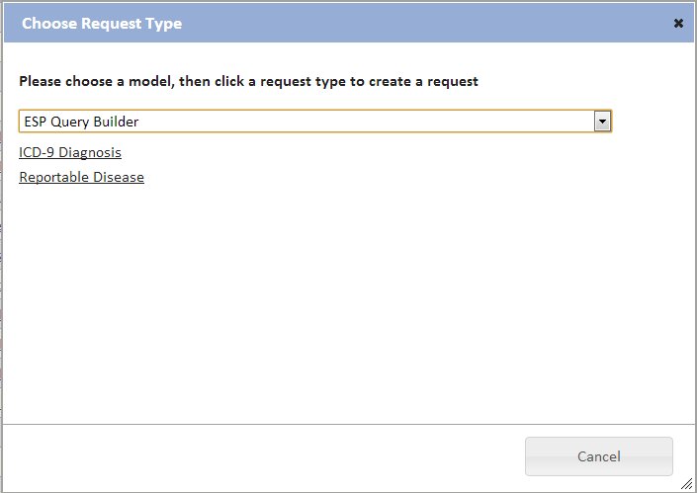

Figure : Request Type Dialog for ESP Query Builder Queries

### ESP ICD-9 Diagnosis Query

To compose an ICD-9 Diagnosis ESP query, click on the “New” button in the request panel, choose “ESP Query Builder”, and then choose the “ICD-9 Diagnosis” request type.

This will display a request detail page used to enter the criteria for this type of request.

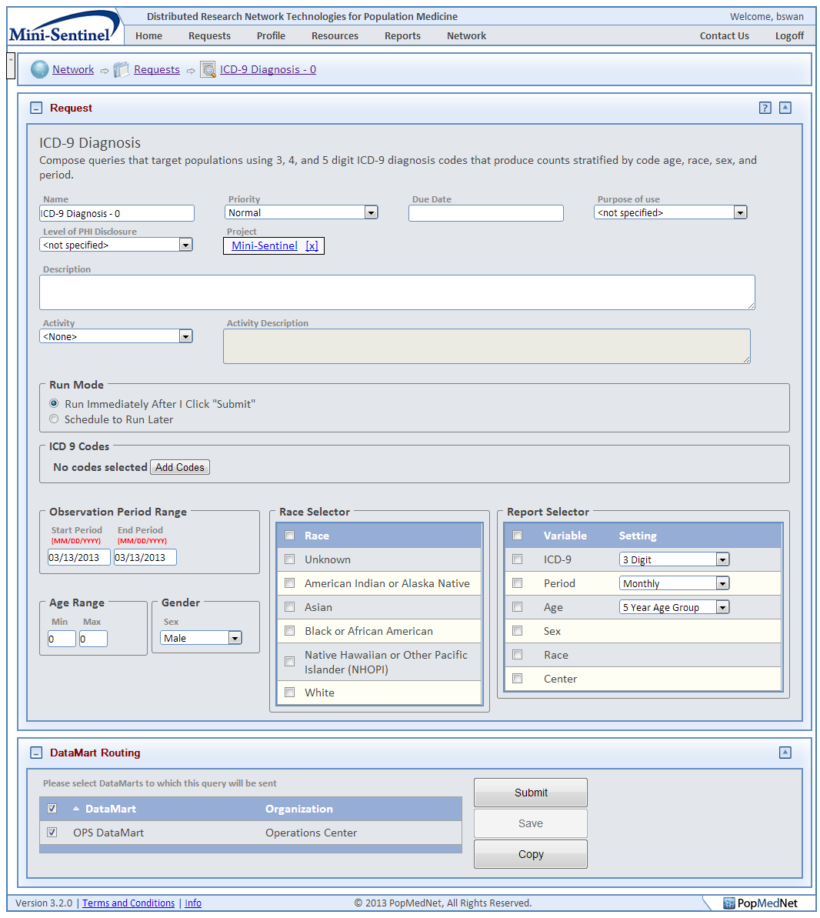

Figure : ESP ICD-9 Diagnosis Request Composer Page

Enter the following criteria for an ICD-9 Diagnoses query:

Table : ESP ICD-9 Diagnosis Query Criteria

| **Control** | **Description** |
| --- | --- |
| **Code Selection** | There are two ways to select the codes:   * Search by specific code (including decimal, for 4 and 5 digit codes), range of codes (e.g., 250-251, 250.1-255.1, or 296.00-296.99) or keyword to identify codes for the query; wild cards (*) can be used. * Choose a category and select from a list. The list shows code and name. Click on the column header to sort by code or by name. Click on **Add Codes** to add the selected codes to the list and display the list.   Note, when ICD-9 codes of 3 or 4 digits are selected, all available codes to the highest degree of specificity will be displayed in the results. For example, selecting the code '250' is equivalent to a query of 250*, results for available codes 250.xx codes will be queried. Each code in the output will be displayed separately by row.  Codes selected will result in a query that returns patient counts that include any of the selected codes or their more specific codes. For instance, selecting 250 and 251 will result in a query that will return counts for all diagnosis of 250 or 250.01-250.09 or 251 or 251.01-251.09.  The code set used for the specifications for this query type is provided by the UMLS (Unified Medical Language System). |
| **Observation Period** | Select the starting period and ending observation period using the date selector. |
| **Age Range** | Select the minimum age and maximum age for the patient population. |
| **Gender** | Select a sex from the drop down menu for the patient population. You may choose from the following list:   * Male * Female * Male and Female |
| **Race** | Select one or more values from the race selector |
| **Report Selector** | Choose one or more values used to stratify the results. For Age, you may choose to group values by 5 year age groups or 10 year age groups. For Period, you may choose to group values by Monthly or Yearly. There is also an option to stratify results by Center (e.g., Community Health Center). |
| **DataMarts** | Select the DataMarts to submit your query to. Only the DataMarts for which you have rights to route your request to are displayed. |

### ESP Reportable Disease Query

To compose an ESP Reportable Disease Query, click on the “New” button in the request panel, choose “ESP Query Builder”, and then choose the “Reportable Disease” request type.

This will display a request detail page used to enter the criteria for this type of request.

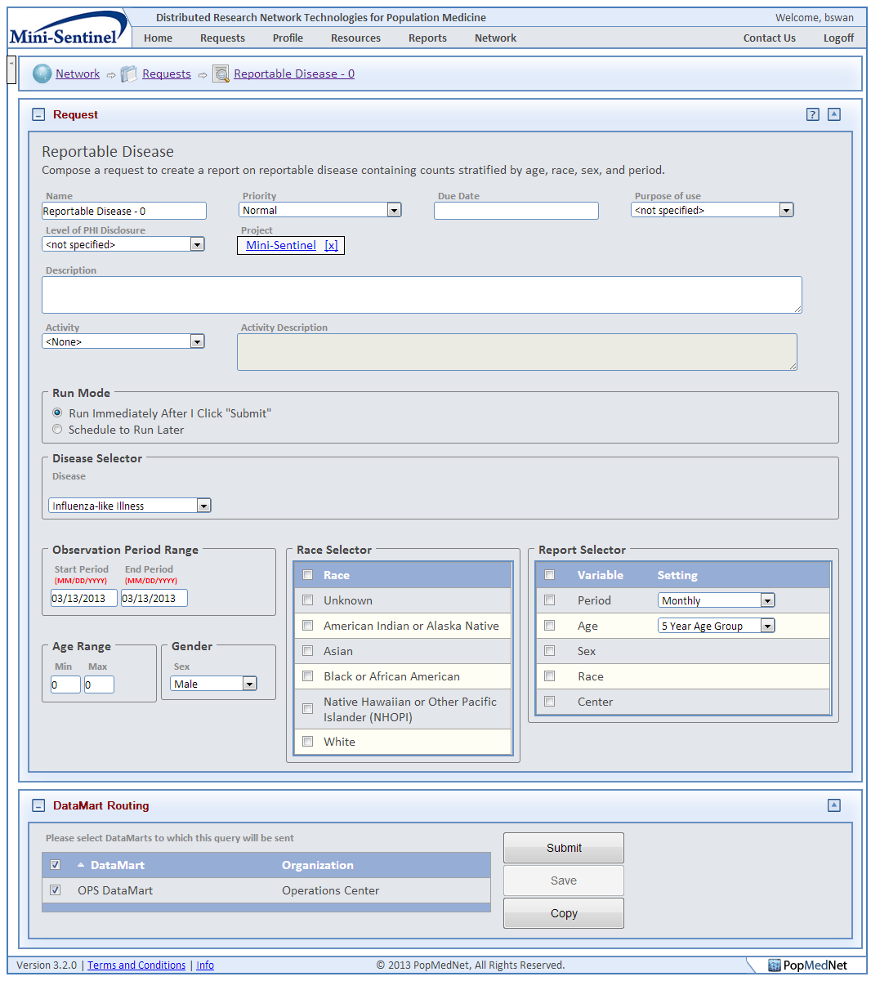

Figure : ESP Reportable Disease Request Composer Page

Enter the following criteria for a reportable disease query:

Table : ESP Reportable Disease Query Criteria

|  |  |  |  |
| --- | --- | --- | --- |
| **Control** | | **Description** | |
| **Disease Selector** | | Choose the reportable disease you wish to query from the available diseases listed in the drop-down control | |
| **Observation Period** | | Select the starting period and ending observation period using the date selector | |
| **Age Range** | | Select the minimum age and maximum age for the patient population. | |
| **Gender** | | Select a sex the drop down menu for the patient population. You may choose from the following list:   * Male * Female * Male and Female | |
| **Race** | | Select one or more values from the race selector | |
| **Report Selector** | | Choose one or more values used to stratify the results. For Age, you may choose to group values by 5 year age groups or 10 year age groups. For Period, you may choose to group values by Monthly or Yearly. | |
| **DataMarts** | | Select the DataMarts to submit your query to. Only the DataMarts for which you have rights to route your request to are displayed. | |

## File Distribution

The File Distribution plug-in allows you to distribute any type of file to the network DataMarts. You can upload files for distribution to a selected DataMart. You create a File Distribution query by selecting the File Distribution model and then the File Distribution request type.

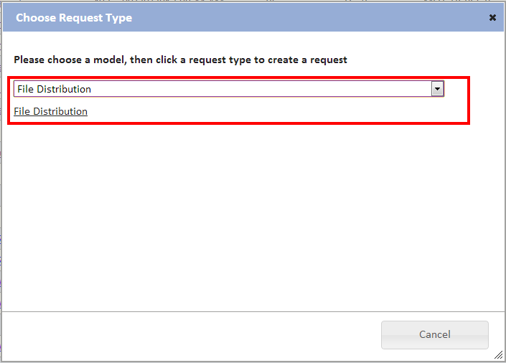

Figure : Request Type Dialog for File Distribution

This navigates you to a form to select the files you wish to send to DataMarts.

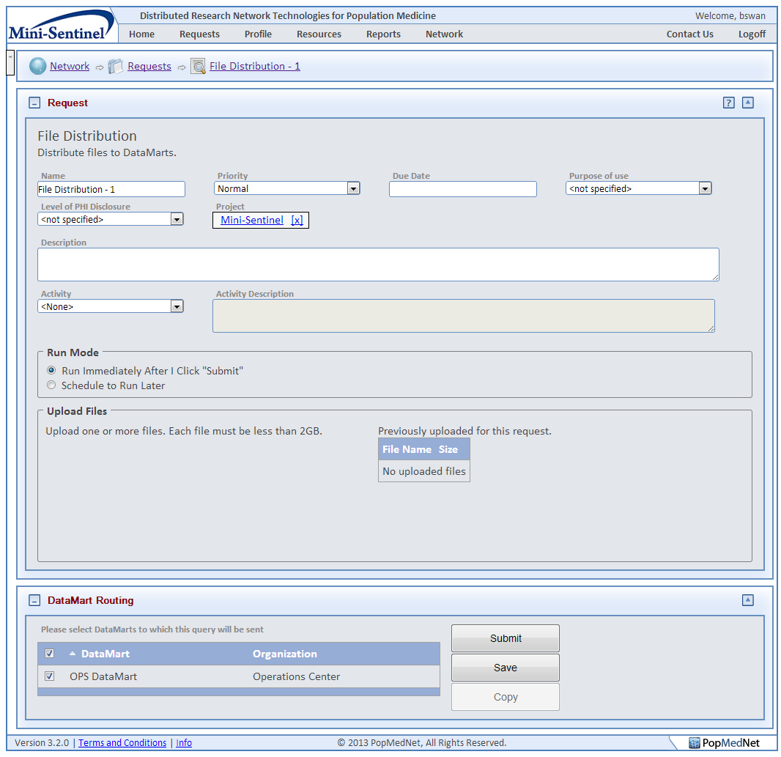

Figure : File Distribution Request Composer Page

Use these steps to upload a file to selected DataMarts:

1. Enter a unique query name.
2. Enter a brief description of the query.
3. Click the Browse button to select a file.
4. After you select each file, click the Upload button.
5. Once you have selected the desired file(s), click the Submit button.

## SQL Distribution

The SQL Distribution plug-in is very similar to the file distribution plug-in as it allows you to distribute raw SQL from the portal to the network DataMarts. You create a SQL Distribution query by selecting the SQL Distribution model and then the SQL Distribution request type.

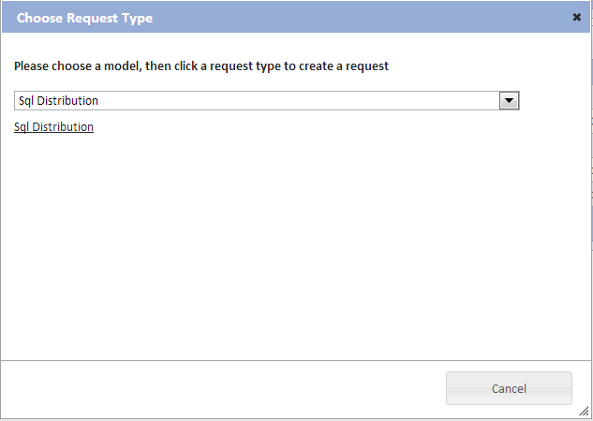

Figure : Request Type Dialog for SQL Distribution

This navigates you to a form where you send the SQL to selected DataMarts.

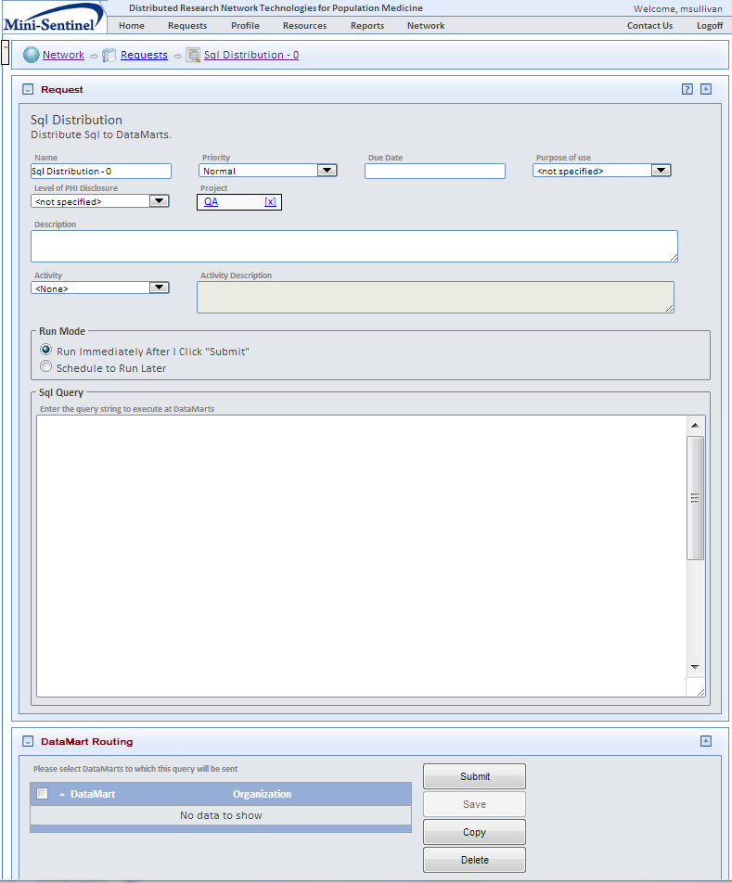

Figure : SQL Distribution Request Composer Page

Use these steps to distribute SQL to selected DataMarts:

1. Enter a unique query name.
2. Enter a brief description of the query.
3. Manually paste the SQL query string into the SQL query section.
4. Once you have selected the appropriate DataMarts, click the Submit button.

# Checking the Query Status

Once a request is submitted, its status is displayed in the Requests list.

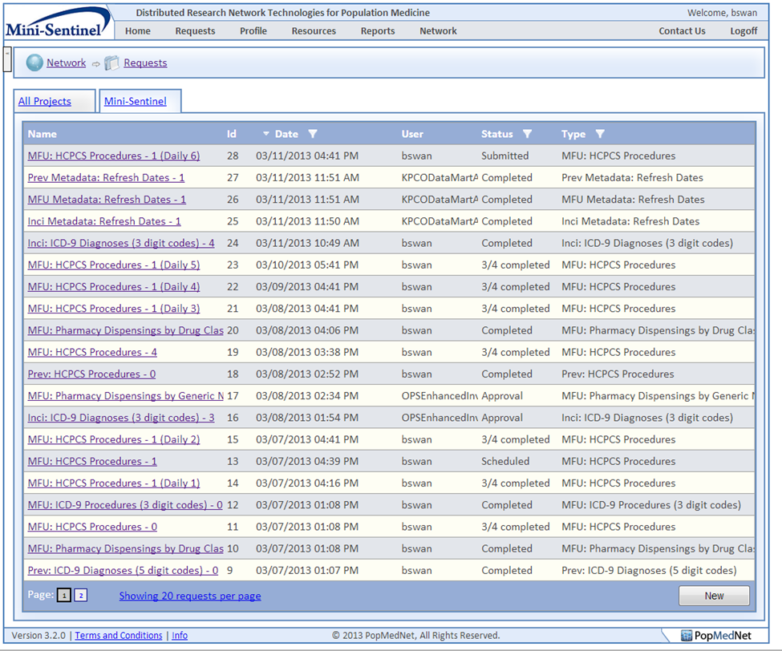

Figure : Request Page

You can view the detailed status of a request by clicking on the request name to navigate to the Request Status detail page.

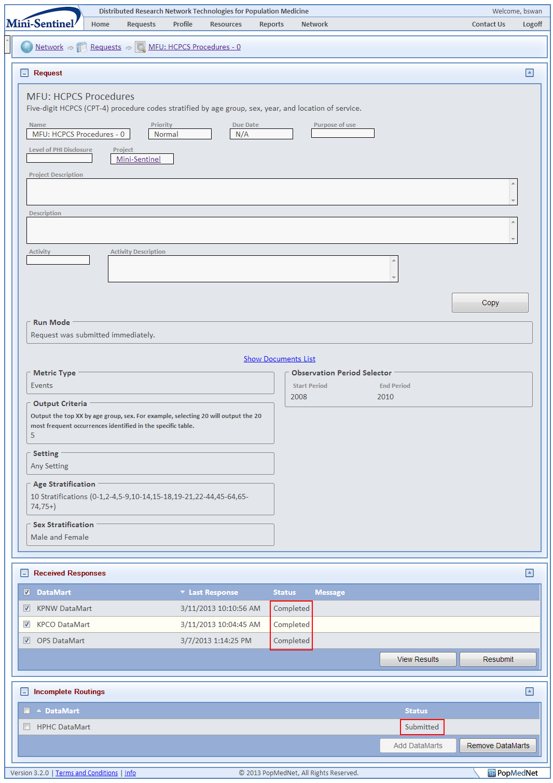

Figure : Statuses on Request Details Page

This displays a list of all the DataMarts to which you submitted the request along with status for each DataMart.

# Viewing Request Results

You can view the results of a request from the Request Detail page by selecting “View Results.”

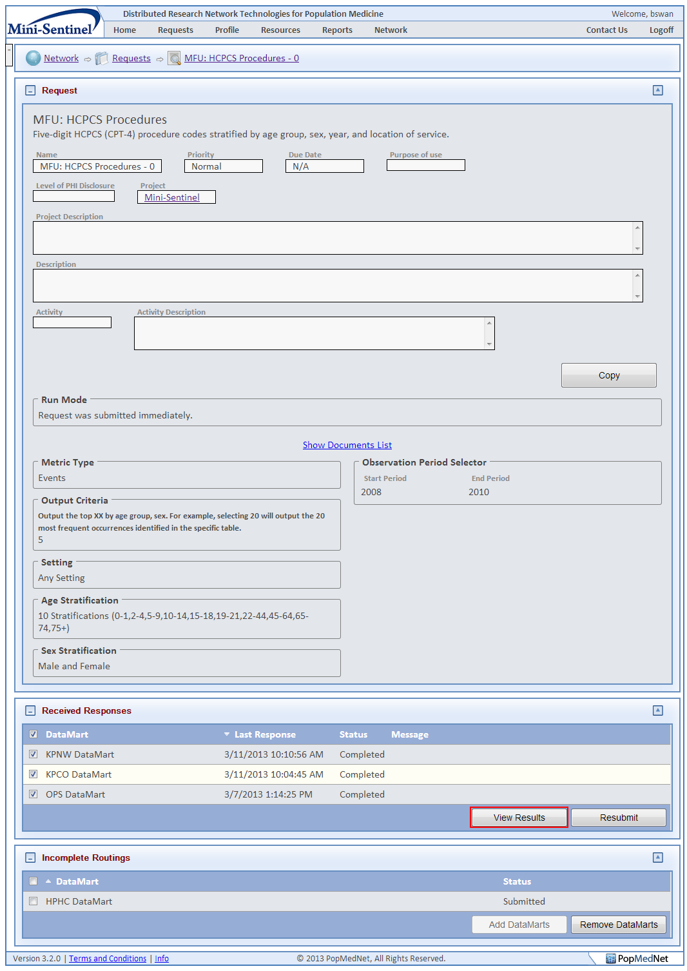

Figure : Request Detail Page - View Results Button

A user designated as an Enhanced Investigator will have the right to view site results individually across the organizations within the query. This role will be assigned at the discretion of a Network Administrator and in accordance with the governance of the network.

**Note**: Be sure to check the status of a query before you view the results. **If you select View Result before all DataMarts have uploaded their results, you will cancel queries which have not yet been responded to** (i.e., you will not be able to see any results from the DataMarts that did not respond to that query). If you want information from those DataMarts, you must submit a new query.

Selecting “View Results” will display the response based on your query parameters in a table.

Note about result stratifications: The patient counts are unique within the designated reporting period (e.g., month-year). For instance, you send an ICD-9 query for 250.1 from 1/2012 through 4/2013 and a person is coded with this in 2/2012, 6/2012, and 2/2013. If the result is stratified by year and month, the patient would be counted in three stratifications. If the query was stratified by year, the patient would be counted twice – one count for each year. A patient can only be counted once per stratification. To prevent double-counting, DO NOT sum person counts across periods.

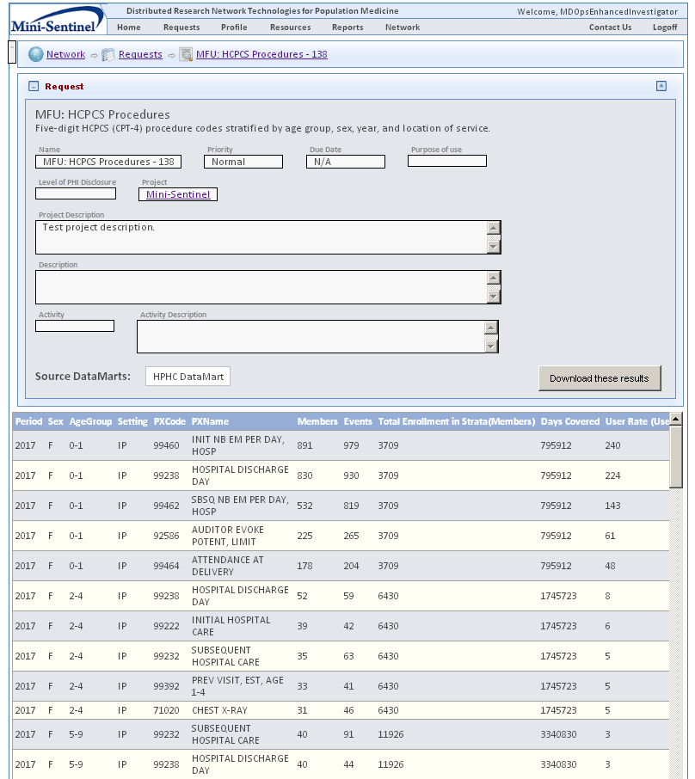

Figure : Request Response Page



# Exporting Result Data

You can export the result data to a CSV File or to Excel from the View Results screen.

Use these steps to export data:

* Choose CSV or Excel from the “Export to:” drop down box.
* Click the Export button

# Adding or Removing DataMarts from Submitted Queries

Before viewing your query result, you can add DataMarts to or remove them from a query.

***Note: You cannot remove a particular DataMart after it has uploaded results to the query.***

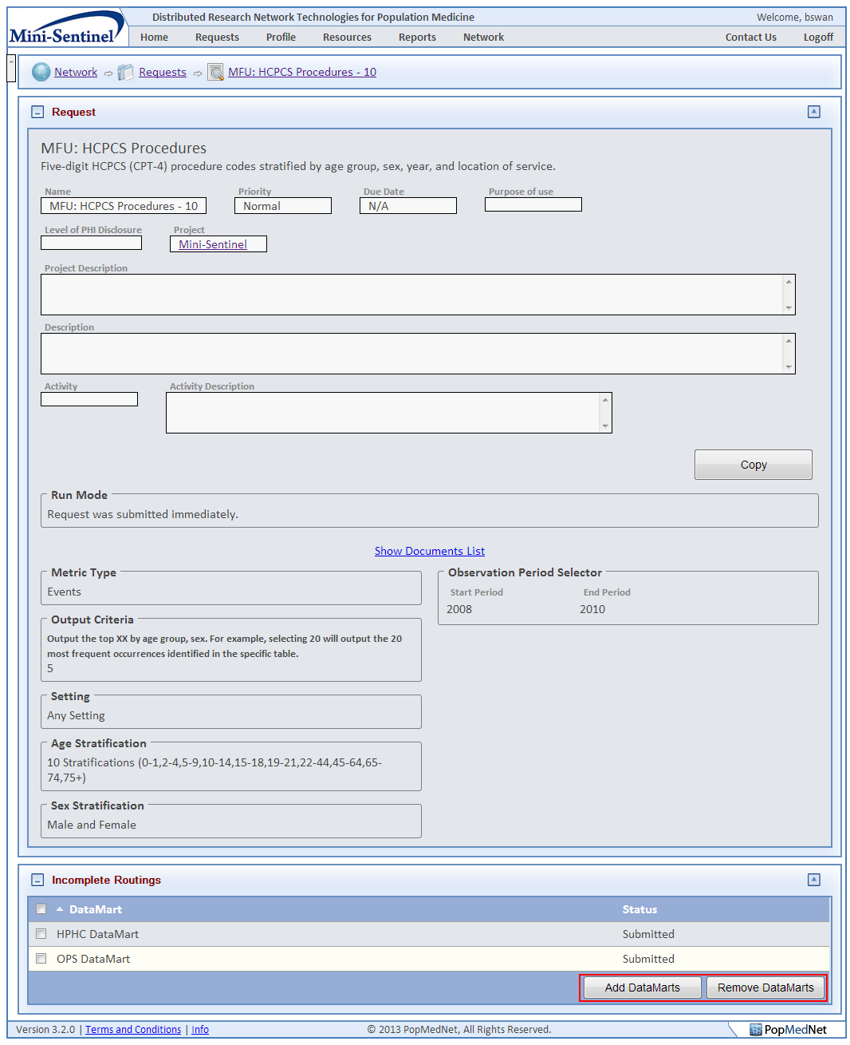

Figure : Request Detail Page - DataMart Routing Buttons

To add DataMart from the query, use the “Add DataMarts” button in the Incomplete Routings panel at the bottom of the request status page. This will display a list of available DataMarts you are allowed to route the query.

To Remove a DataMart from the query, first select the DataMart using the checkbox control to next to the DataMart name, then click the “Remove DataMarts” button.



# Administering your User Profile

You must be logged in to the web portal to administer your user profile. Select “Profile” from the main menu to display your user profile. Use this page to change contact information, password, and notification settings.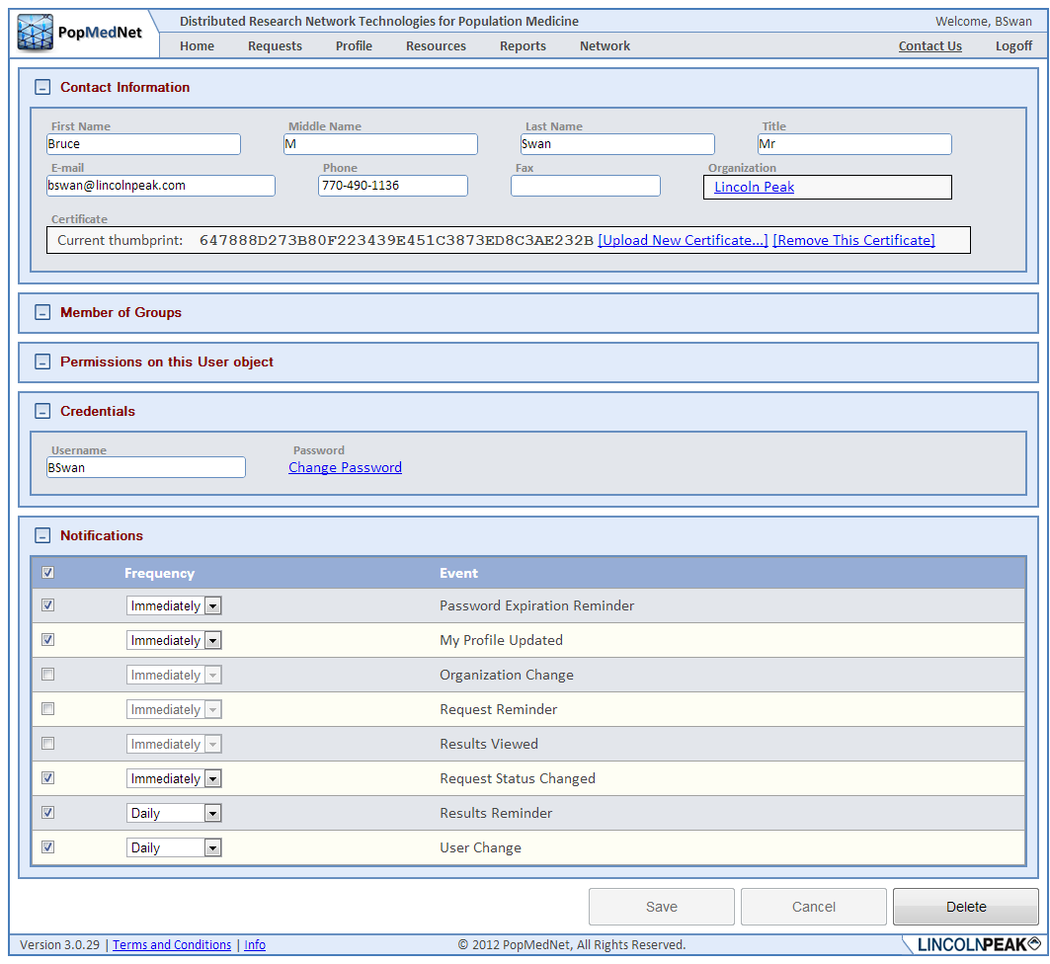

Figure : User Profile Page



## How to Reset your Password

Your user profile has two boxes for passwords. To change your password:

* Enter the new password in the first Password box.
* Re-enter the new password in the second Password box.
* Click the Save button.

**Note:** All passwords must meet the following complexity standard:

* Length must be at least 7 characters
* Password must include at least 1 upper case letter, 1 lower case, 1 number, and 1 symbol.

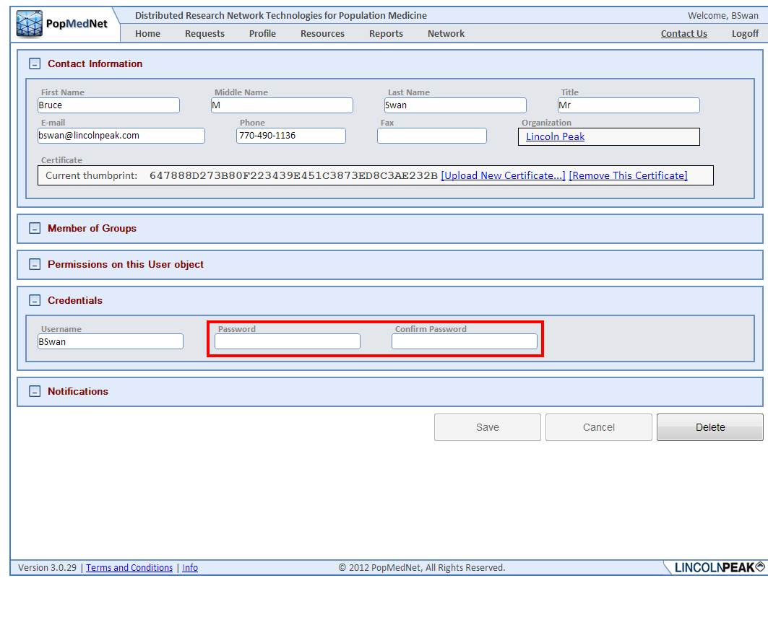

Figure : User Profile Page - Password Boxes

Once you initially get your login credentials from the system administrator, it is highly advised that you change your password from the default password given to you.

## Notifications

Notification options allow the user to manage events that are triggered due to actions performed by the user or related to the user’s role, such as a Query Administrator. Users have the option of receiving notifications immediately when they are triggered, daily, weekly, or monthly. When choosing daily, weekly, or monthly, the notifications are batched together with other notifications on the same schedule in a single email.

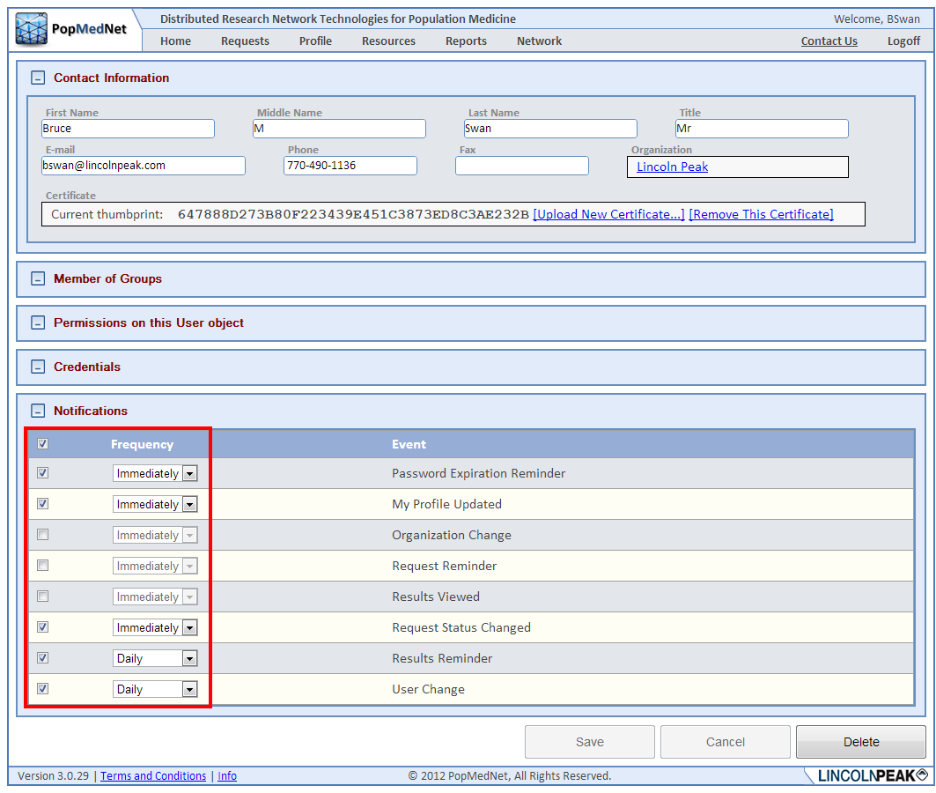

Figure : User Profile Page - Notification Options

***Note: Once the user has chosen to receive notifications, regardless of the delivery frequency selected; the notifications are displayed in the Notifications panel on the Home page.***

The notification options displayed in your profile are dependent on the roles or privileges that have been granted to you. The following is a complete list of notifications.

Table : Notifications

| Category | Event | Description |
| --- | --- | --- |
| User | Password Expiration Reminder | Notifies the user that their password is about to expire. |
|  | My Profile Change | Notifies the user there was an update to their profile. |
|  | User Change | Notifies administrators there was a user added, deleted, or updated. |
|  | New User Registration Submitted | Notifies administrators a new user request has been submitted. |
|  | Registration Change | Notifies administrators there has been a change to a user registration request. |
|  |  |  |
| Requests | New Request Submitted | Notifies DataMart administrators that a new request has been submitted. |
|  | Request Status Changed | Notifies investigators and administrators that a change has been made to a request. |
|  | Request Reminder | Reminds DataMart administrators there is a pending request that requires their attention. |
|  | Results Reminder | Reminds administrators and investigators that results have been uploaded for their request. |
|  | Results Viewed | Notifies administrators that a result has been viewed. |
|  |  |  |
| Organization | Organization Change | Notifies administrators that an organization has been added, updated, or deleted. |
|  |  |  |
| Group | Group Change | Notifies administrators that an group has been added, updated, or deleted. |
|  |  |  |
| DataMart | New DataMart Client Version is Available | Notifies DataMart administrators that a new version of the DataMart Client application is available. |
|  | DataMart Change | Notifies administrators that a DataMart has been added, updated, or deleted. |

# Getting Help

Once logged in, the Resource Tab offers helpful contact information, documentation, and related links, as seen below.

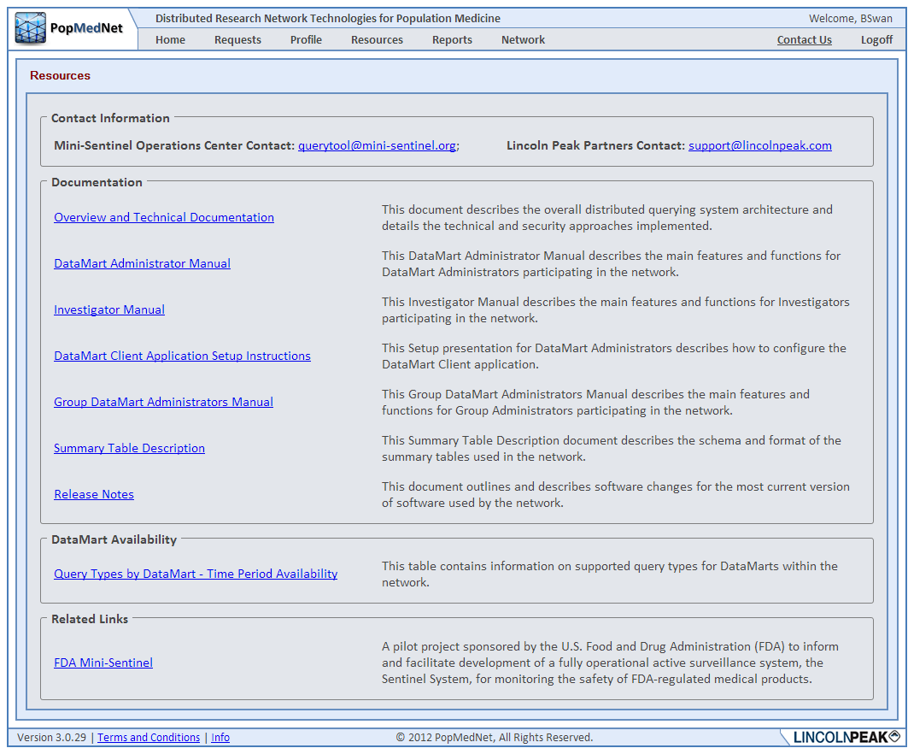

Figure : Resources Page

If you have trouble accessing the Web Portal or your user account, click on the Contact Us link and describe your issue to request help from the PopMedNet™ support staff.

# Development and Funding Statement

The **PopMedNet™** software application was developed as part of several contracts awarded by the Agency for Healthcare Research and Quality (AHRQ) to the HMO Research Network (HMORN) Center for Education and Research on Therapeutics (CERT) DEcIDE Center housed in the Department of Population Medicine at the Harvard Pilgrim Health Care Institute (HPHCI). Additional development was funded by AHRQ under the Scalable PArtnering Network for CER: Across Lifespan, Conditions, and Settings (SPAN) project. Additional support has been provided by The Food and Drug Administration’s Mini-Sentinel project (Contract No. HHSF223200910006I) and the US Department of Health and Human Services Office of the National Coordinator for Health Information Technology (ONC) MDPHnet project.

The system was developed by Lincoln Peak Partners under the direction of HPHCI.

# Frequently Asked Questions

 This section lists some of the most frequently asked questions.

* What is the difference between Groups, Organizations, and Users?
  + Users are individuals with various roles and associated rights within the system such as Investigator, DataMart Administrator, and System Administrator. Organizations have one or more users and zero, one, or more DataMarts. Users are members of a single Organization. Groups are collections of one or more Organizations and an Organization may be a member of zero, one, or more Groups. Groups allow management of a collection of organizations by a set of administrators.
* What are my rights as a user and how can I change them?
  + Rights can be assigned to individual user accounts for to various security groups for which the user is a member by the Network Administrator or the user’s Organization Administrator.
* Where can I get more information on the PopMedNetTM application?
  + You may contact the Operations Center for more information:

Jeffrey Brown, PhD

Harvard Pilgrim Health Care Institute

[Jeff_brown@hphc.org](mailto:Jeff_brown@hphc.org)

[www.popmednet.org](http://www.popmednet.org)

* When I viewed my results, I got the error message “No data available for display.” What does this mean?

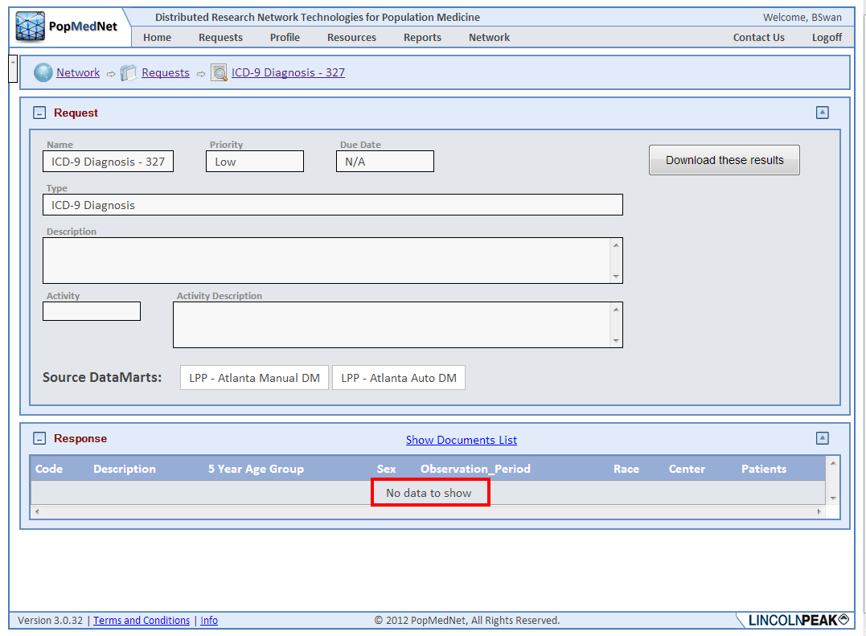

Figure : Request Response Page - Empty Results

This means that the sites queried had no data in their database that matched your query specifications so an empty set was returned to the portal

# Appendix A: Quick Reference for Investigators

**Quick Reference: Investigator**

1. How to Submit a Query
   1. Log into the Portal with your credentials.
   2. Click the New button in the Requests panel and select the Summary Query request model and then choose the type of request from the list.
   3. Complete the request form by entering a name, brief description of the query, and selecting the relevant parameters.
   4. Select the DataMarts (Data Partners) who you would like to send the query.
   5. Click *Submit*.
2. How to Distribute a File
   1. Log into the Portal with your credentials.
   2. Click the New button in the Requests panel and select the File Distribution request model and then choose the File Distribution request type.
   3. Complete the File Distribution form by entering a name and a brief description of the file(s) you are sending.
   4. Browse and upload your file(s) you wish to send to DataMarts.
   5. Select the DataMarts (Data Partners) who you would like to send the file(s).
   6. Click *Submit* button.
3. How to View Results on the Portal
   1. Log into the Portal with your credentials and go to the *Requests* list panel on the home page or click Requests from the top menu.
   2. Find and click on the request name for which you wish to see the results to navigate to the Request Status page.
   3. When all sites have responded, click *View Result*. Enhanced Investigators may view site-specific results by checking a site and clicking *View Selected Results.*
   4. Export result data to Excel/CSV or download returned files for review.

# Appendix B: Query Administrator Role

The Query Administrator acts as a gatekeeper for all the queries coming out of an organization. Given budgeting for queries, this role can monitor query submission so that only the most relevant queries are distributed to the sites in the network.

Once an investigator within the organization submits a query, the request status is marked as “Approval” as shown in the following figure.

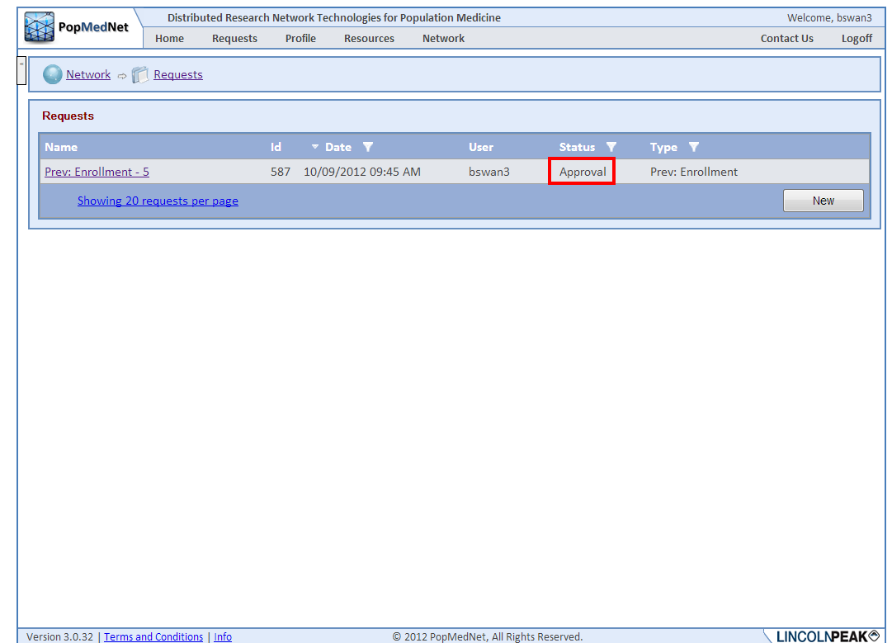

Figure : Request Page - Approval Request Status

Clicking on the request name navigates the user to the request status page where they see its status.

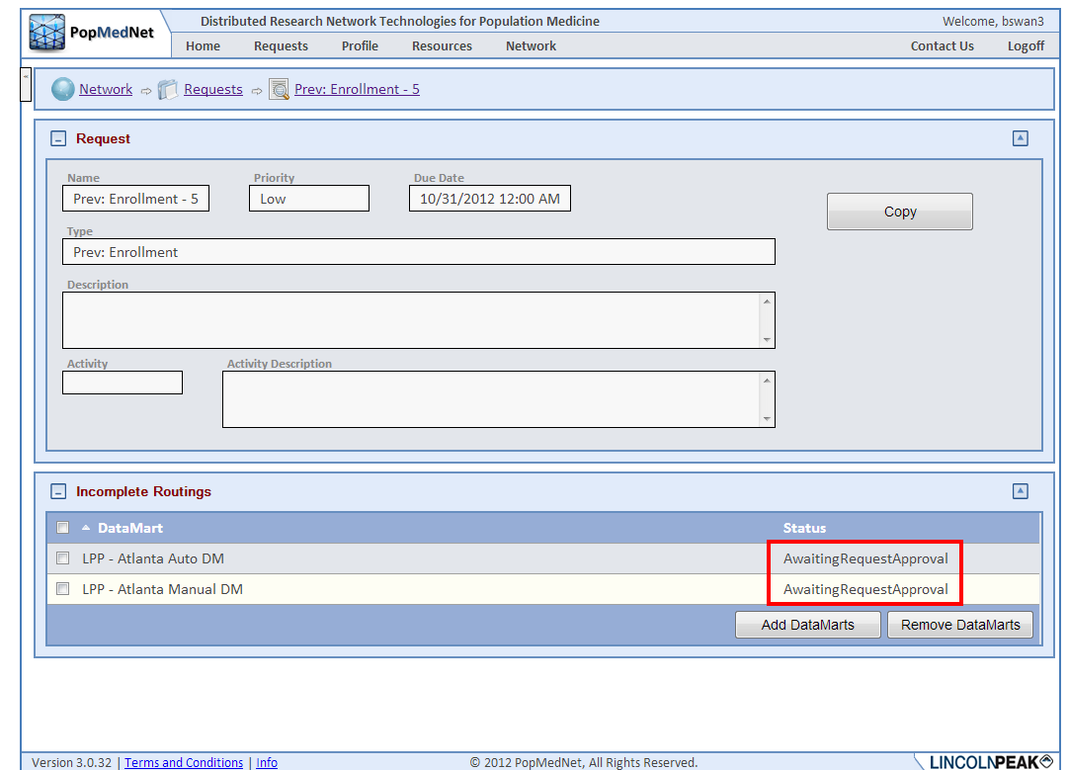

Figure : Request Detail Page - Awaiting Response Approval Routing Statuses

The query administrator receives an email notification about a query that is “Awaiting Request Approval”. When the Query Administrator then logs in with their login credentials, they will see the new request waiting for approval in their request list.

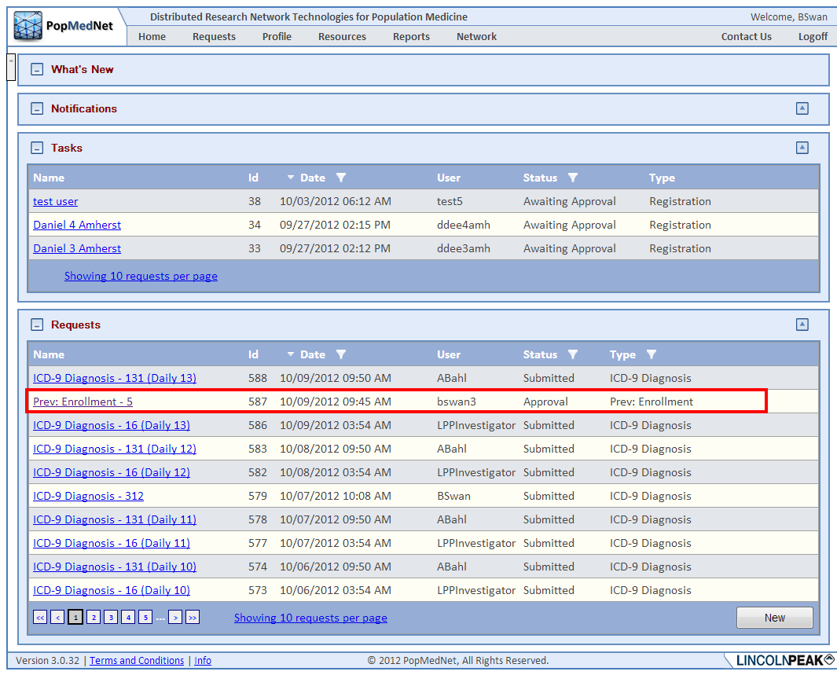

Figure : Request Page - Request Awaiting Approval

Clicking request name will navigate the query administrator to the request status page where they can review, approve, or reject the query along with comments.

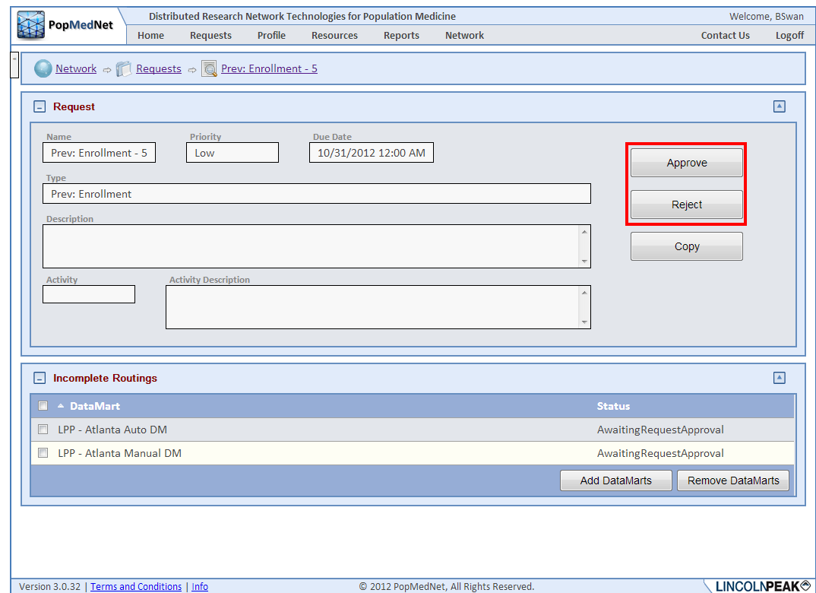

Figure : Request Detail Page - Approve and Reject Options

As results are uploaded to the query, the Query Administrator can view individual site results, just like an Enhanced Investigator. Query Administrators can also submit queries.